**UI Design**

My app is designed mainly for mobile devices in portrait mode. The layout, buttons, and text are created to fit a normal upright screen perfectly. The goal is to make it easy for users to use with one hand and understand everything quickly, even if they are new to the app. The design uses Tailwind CSS to make all components responsive within the portrait layout, keeping everything balanced on small screens. The spacing between buttons and cards is wide enough so users can tap easily without pressing the wrong area.

When users open the app, the Home Screen appears first. It shows a vertical list of recipe cards from the JSON file. Each card has the recipe name, image, cuisine, and rating, which helps users choose what they want to cook. When a user taps a card, it takes them to the Recipe Detail Screen, which displays all details such as ingredients, steps, cooking time, servings, tags, nutrition, and reviews. The layout is scrollable, so users can easily read everything from top to bottom. The top bar includes two icons — a heart for saving recipes and a plus sign for adding ingredients. Both are placed in the top-right corner for easy access while holding the phone.

The bottom navigation bar appears on all main screens and includes Home, Daily Specials, Favourites, and Ingredients. Each icon has a short text label to make it clear. When users tap an icon, the app switches smoothly to that section. The Daily Specials Screen shows five random recipes that are Easy or Medium difficulty, giving users quick daily inspiration. The Favourites Screen lists saved recipes, and the Ingredients Screen shows saved ingredients grouped by category, each with a trash icon for easy removal.

Every action in the app has visual feedback. For example, when a button or card is pressed, it changes colour slightly to confirm the tap. If something is loading, a small spinner appears, and when there are no saved items, a simple message like “No recipes found” is displayed. This makes the experience friendly and clear.

The design also focuses on accessibility. Text is large and readable, colour contrast is strong, and icons are simple. The app avoids clutter, keeping enough space around each item. Since the layout stays in portrait mode, everything is positioned for quick scrolling and easy touch control.

**Wireframe Design**

Home Page

Recipe Details Screen  
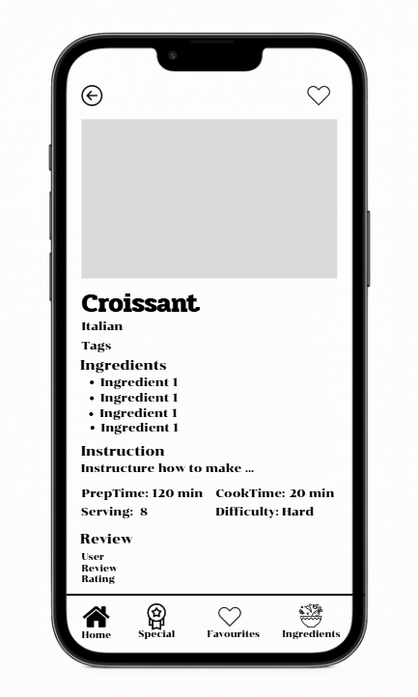

This recipe detail screen shows the full details of a selected recipe including the image, cuisine, ingredients, instructions, preparation and cooking time, servings, difficulty, and user reviews, all neatly arranged for easy reading on a small screen.